
TAMPINES JUNIOR COLLEGE

Preliminary Examinations 2010

CHEMISTRY (Higher 2) 9647/02

PAPER 2 Structured Questions

Tuesday 14 September 2010 2 hours

Additional materials: Data Booklet

INSTRUCTIONS TO CANDIDATES
Write your answers on the Question Paper.

Write your name and Civics Group on all the work you hand in.
Write in dark blue or black pen on both sides of the paper.
Do not use staples, paper clips, highlighters, glue or correction fluid.

Answer all questions.

The number of marks is given in brackets [ ] at the end of each question or part question.
Name : _____________________  CG : ________ |  | Question | Marks
 |  | 1
 |  | 2
 |  | 3
 |  | 4
 |  | 5
 |  | 6
 |  | 7
 |  | TOTAL | / 72

This document consists of 15 printed pages.
[Turn over

Answer all the questions in the space provided.

Question 1 [12 marks]

Planning

Hydrochloric acid reacts with solid calcium carbonate in the form of marble chips. The products of the reaction are aqueous calcium chloride, carbon dioxide and water.

The rate in which a reaction will proceed is dependent on many factors (variables). You are to plan an investigation to find how changes in one of these variables affect the rate of reaction between solid calcium carbonate and hydrochloric acid.

(a) Write a balanced equation, including state symbols, for the reaction between solid calcium carbonate and hydrochloric acid. [1]

2HCl(aq) + CaCO₃(s) → CaCl₂(aq) + CO₂(g) + H₂O(l)

(b)(i) The concentration of the hydrochloric acid is one independent variable that could be investigated. Identify two other independent variables that could be investigated. [2]

• Temperature
• Size or surface area of calcium carbonate

(ii) Identify a dependent variable that you could measure to follow the rate of reaction. [1]

Volume of CO₂ evolved

(c) Propose a hypothesis that can be tested experimentally and that relates the rate of reaction and the concentration of the hydrochloric acid. [1]

Rate of production of CO₂ increases with increasing concentration of hydrochloric acid.

(d) Design a laboratory experiment that you would use to investigate your hypothesis. You should draw a labelled diagram showing the arrangement of your apparatus. Your plan should include the following.

(i) a step-by-step description of the procedure you would follow
(ii) how you would measure and vary the independent variable
(iii) how you would control the other two variables that you identified in part (b)
(iv) any safety precautions that you would take
(v) appropriate quantities (masses, volumes, concentrations) to use in the experiment

[Ar: Ca, 40.1; C, 12.0; O, 16.0]
Hydrochloric acid has an approximate concentration of 2.0 mol dm⁻³.
[7]
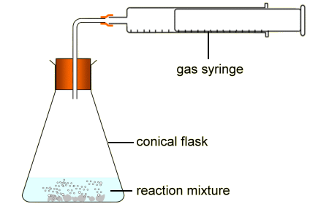

Procedure

- Weigh accurately 0.42g of CaCO₃ using a conical flask.

Volume of CO₂ to be collected = 100 cm³

Amount of CaCO₃ = Amount of CO₂ collected

= 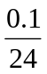

= 4.17 x 10⁻³ mol

Mass of CaCO₃ = 4.17 x 10⁻³ x 100.1

= 0.420 g (3s.f)

- Add 5 cm³ of HCl acid to a 50 cm³ measuring cylinder and make up the volume to 50 cm³ by adding deionised water.
(HCl acid is irritant. Wash all spillage with plenty of water.)

Amount of HCl = 2 x Amount of CaCO₃

= 8.34 x 10⁻³ mol

[HCl]_{initial} = 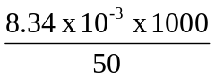

= 0.167 mol dm⁻³
Control of temperature – All 5 sets of experiments must be carried at
the same time OR use a water bath.

Size of marble chip - Same mass & similar size.

- Pour HCl acid prepared in step 1, into the conical flask and stopper the opening of the flask as shown in the labelled diagram. Immediately, start the stopwatch.

- Swirl the flask to ensure even mixing.

- Record, in the table below, the time taken (to the nearest second) to collect 100 cm³ of CO₂.

- Rinse out the conical flask thoroughly with water.

- Repeat steps 1 to 6 using different volume of HCl acid and water as shown in the table below.

Experiment | Volume of HCl acid / cm³ | Volume of deionised water  / cm³ | [HCl] / mol dm⁻³
1 | 5.0 | 45 | 0.2
2 | 10.0 | 40 | 0.4
3 | 15.0 | 35 | 0.6
4 | 20.0 | 30 | 0.8
5 | 25.0 | 25 | 1.0

Question 2 [10 marks]

In catalytic hydrogenation of benzene as shown below, a catalyst known as Raney nickel is commonly used. Raney nickel is produced when a block of nickel-aluminium alloy is treated with concentrated sodium hydroxide.

The aluminium-containing product of this reaction is the same as that obtained from the reaction between aluminium oxide and sodium hydroxide. The porous structure of the catalyst arises from the selective removal of aluminium from alloy particles using concentrated sodium hydroxide solution.

When a 2.50 g sample of this alloy was reacted with concentrated sodium hydroxide, 0.0500 mol of hydrogen gas was produced at 28 ºC and a pressure of 1.5 atm.

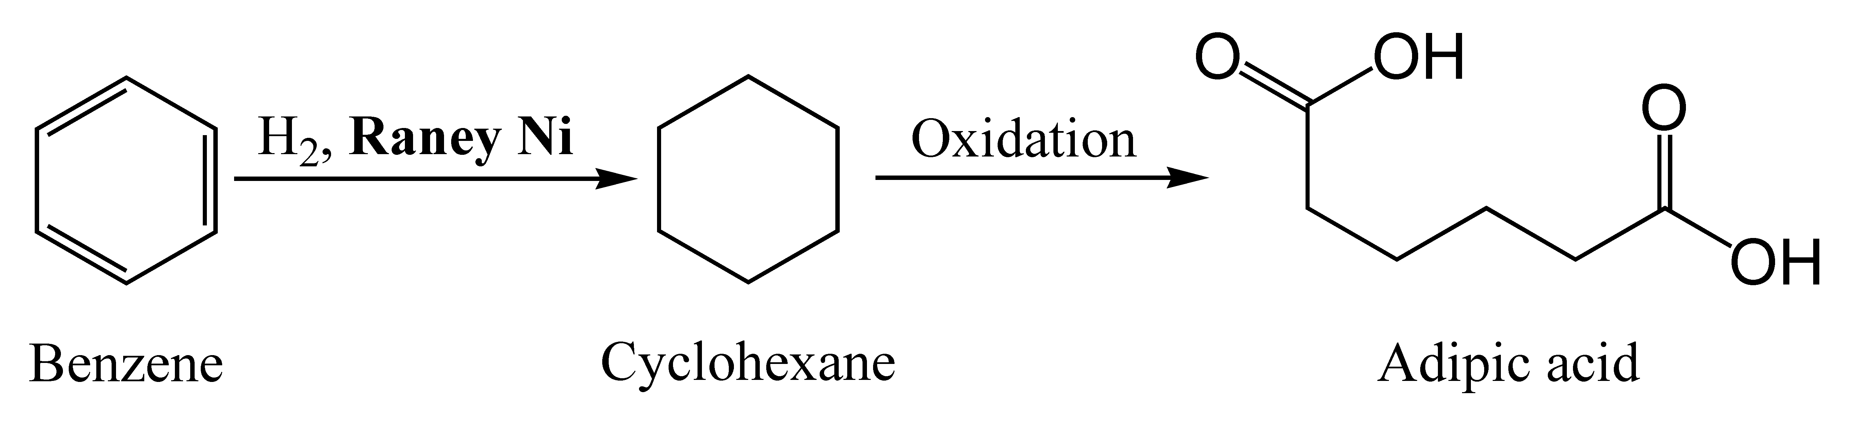
3 steps

(a) | Construct a balanced equation for the reaction between aluminium and sodium hydroxide. [1]  2Al + 2NaOH + 6H₂O → 2NaAl(OH)₄ + 3H₂  OR  2Al + 2OH– + 6H₂O →  2[Al(OH)₄]– + 3H₂
(b) | Calculate the volume of hydrogen gas obtained in cm³. [2]  pV = nRT  (1.5 x 1.01 x 10⁵) x V = 0.0500 x 8.31 x (28 + 273)  Volume of H₂ gas = 8.26 x 10⁻⁴ m³  = 826 cm³
(c) | Hence calculate the percentage composition of aluminium in the sample of alloy. [2]  Amount of Al =  X Amount of H₂  = 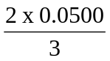  = 3.33 x 10⁻² mol  % composition of Al in the alloy sample = 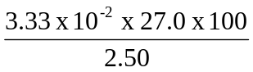  = 36.0 %
Today, the typical modern ammonia-producing plant first converts natural gas (i.e., methane) or liquefied petroleum gas (such gases are propane and butane) or petroleum naphtha into gaseous hydrogen. Catalytic hydrogenation converts gaseous organosulfur compounds such as CH₃CH₂SH into its corresponding hydrocarbon and hydrogen sulfide.
(d) | Construct the equation, with state symbols for the above reaction. [1]  H₂ (g) + CH₃CH₂SH (g) CH₃CH₃ (g) + H₂S (g)
(e) | Write the K_{p} expression for the above reaction. [1]  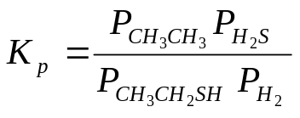
(f) | A 1:1 mixture of H₂ and CH₃CH₂SH was allowed to reach equilibrium at 500 ⁰C and a total pressure of 4 atm. The partial pressure of H₂S at equilibrium was found to be 1.25 atm. Calculate the K_{p} value. [2]  At equilibrium, 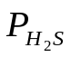 = 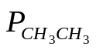  = 1.25 atm  Therefore, at equilibrium, 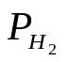= 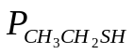  = 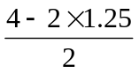  = 0.75 atm  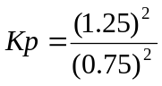  = 2.78
(g) | Predict and explain whether an increase in pressure will affect this equilibrium.  [1]  Increase in pressure will not affect the equilibrium since there is the same number of moles of gas on both sides of the equilibrium.
Question 3 [7 marks]

Spinach, along with other green leafy vegetables, is considered to be a rich source of iron. However, spinach contains iron absorption inhibiting substances, including high levels of oxalate which can bind to the iron to form ferrous oxalate, which renders much of the iron in spinach unusable by the body.

A 35.0 cm³ sample of iron (II) oxalate, FeC₂O₄ extracted from 150 g of spinach, was diluted in water and the solution made up to 250 cm³. A 25.0 cm³ portion of this solution was acidified and titrated with 13.45 cm³ of 0.020 mol dm⁻³ potassium manganate (VII) to give a yellow solution.
(a) | State the change in oxidation number for manganese and carbon. [2]  The oxidation number of Mn decreases from +7 in MnO₄– to +2 in Mn²⁺.  The oxidation number of C increases from +3 in C₂O₄^{2–} to +4 in CO₂.
(b) | Write an overall equation for the reaction between potassium mangante(VII) and iron (II) oxalate. [1]  5FeC₂O₄ + 3MnO₄– + 24H⁺ → 5Fe³⁺ + 10CO₂ + 3Mn²⁺ + 12H₂O
(c) | Calculate the concentration, in mol dm⁻³, of iron (II) oxalate in the original sample. [3]  5FeC₂O₄ ≡ 3MnO₄–  Amount of FeC₂O₄ in 25.0 cm³ portion = 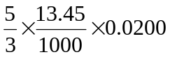  = 4.48 x 10⁻⁴ mol  Amount of FeC₂O₄ in the original sample = 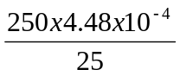  = 4.48 x 10⁻³ mol  Original [FeC₂O₄] = 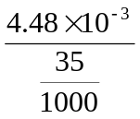  = 0.128 mol dm⁻³
(d) | Calculate the number of moles of iron in each gram of spinach. [1]  Number of moles of Fe in 1 gram = 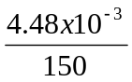 = 2.99 x 10⁻⁵
Question 4 [8 marks]

(a) The graph below shows a plot of the atomic radii of the elements from sodium to chlorine.

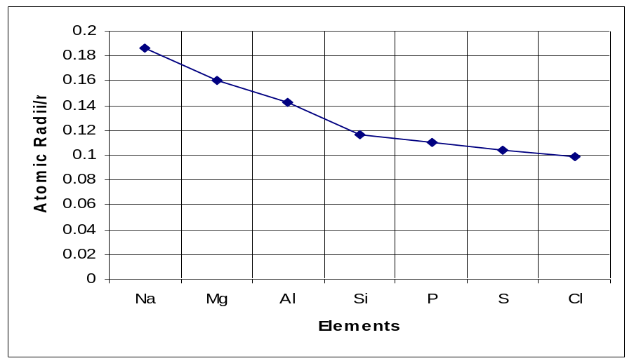
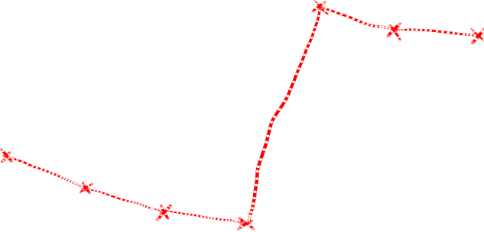

(i) Explain the general trend in atomic radii of these elements across the period.[2]

Across the period, nuclear charge (OR number of protons) increases but
screening effect remains the same,

resulting in the overall decrease in atomic radii.

(ii) Using the Data Booklet, plot the ionic radii of these elements in the same graph
above. [1]

Refer to graph.

(iii) Comment on the shape of the graph that you plotted in (ii). [2]
Anions larger than cations due to increased shielding effect from the extra shell of electrons in anions.
Cationic radius decreases from Na to Si as nuclear charge/proton number increases but number of valence electrons remains the same (OR shielding effect remains the same).
Anionic radius decreases from P to Cl as nuclear charge/proton number increases and the number of valence electrons remains the same.

(b) | Phosphorus pentachloride is a dangerous substance as it reacts violently with water to produce white steamy fumes. It is used as a chlorinating agent and as a catalyst. One common use of phosphorus pentachloride is in the manufacture of chlorophosphazenes, a group of flame retardants.
(i) Explain why PCl₅ exists in nature but NCl₅ does not exist. [2]

P can expand its octet structure because it can make use of 3d orbitals for bonding.

However, N does not have d orbitals hence it cannot expand its octet structure.

(ii) Write a balanced equation to show the reaction of PCl₅ in water. [1]
PCl₅ + 4 H₂O → H₃PO₄ + 5 HCl

Question 5 [9 marks]

The structural formula of a compound R is shown below.
O
O
OH
O

CH₂ – C – CH₃

(a) Compound R undergoes a 2 step reaction to produce Compound Z. Draw the intermediate product and state the reagents and conditions used for both steps.
[3]
O
O
OH
O
intermediate product
Step 1
O
O
OH

CH₂CH(OH)CH₃
CH₂ – C – CH₃

Compound R
Step 2
O
O
OH
Step 1: LiAlH₄, reflux in dry ether

Step 2: Excess concentrated H₂SO₄, 170 ºC CH₂CHCH₂
Compound Z

(b) | Draw the structural formula(e) of the organic product(s) formed when compound R reacts with each of the following reagents. [6]

Reagent | Structural formula(e) of the organic product(s)
Aqueous alkaline I₂ | O  O  OH  O  II  CH₂ – C – O– + CHI₃
Acidified potassium dichromate(VI), reflux | CH₂COCH₃  O  OH  OH  O
Ethanoyl Chloride | O  O  OCOCH₃  O  II  CH₂ – C – CH₃
Aqueous NaOH, reflux | OH  CH₂COCH₃  O  O⁻ Na⁺  O⁻ Na+
Thionyl chloride | O  O  Cl  O  II  CH₂ – C – CH₃

Question 6 [11 marks]

(a) Maleic acid or cis-butenedioic acid is an organic compound that is a dicarboxylic acid. Maleic acid has become a new acidulant in the food and beverage industry. It can enhance special fruit aroma and improve the taste in food and beverage. Maleic acid is mainly used in syrup, readytea, orange juice, sports beverage and other fortified syrup and food.

(i) Draw the structure of cis-butenedioic acid. [1]

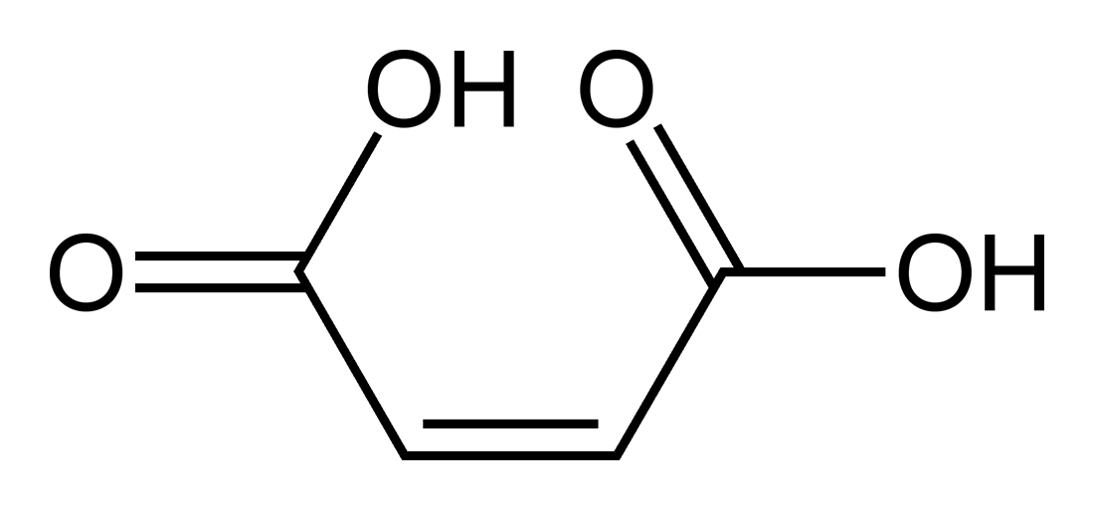

- Fumaric acid is the trans isomer and its physical properties are very different fom maleic acid. The melting point of maleic acid is about 140 °C whereas the melting point of fumaric acid is 287 °C.

Explain why there is a difference in melting point for these two isomers. [2]

The closeness of the COOH groups in maleic acid results in more intramolecular hydrogen bonding and less intermolecular hydrogen bonding whereas the COOH groups in fumaric acid are far apart and results in only intermolecular hydrogen bonding.

Hence, more energy is required to break the intermolecular hydrogen bonds between the molecules of fumaric acid than between the molecules of maleic acid resulting in a higher melting point for fumaric acid.

(iii) In industry, maleic acid is derived from maleic anhydride by hydrolysis.
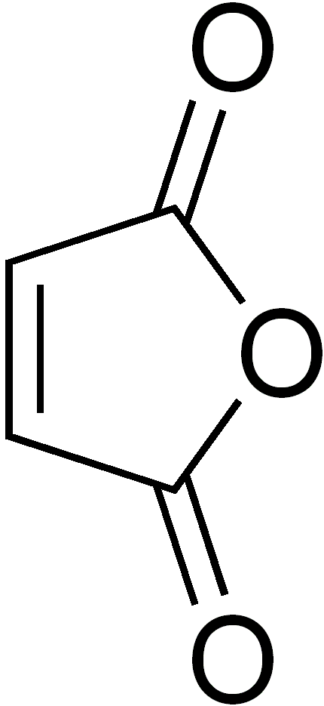 maleic anhydride
By means of a simple chemical test, show how you would distinguish maleic anhydride from maleic acid. [2]
Add aqueous Na₂CO₃ to each of the compound.

Effervescence will be seen for maleic acid but not for maleic
anhydride.

(b) | Novocaine is a synthetically created derivative of cocaine and is used as an anesthetic in minor surgeries.  Novocaine H₂N C−O−CH₂CH₂ −N(CH₂CH₃)₂  ll  O
(i) Besides the phenyl group, name the functional groups present in Novocaine. [1]

Amine (1º and 3º) and ester

(ii) Compare and explain the basicity of Novocaine to that of phenylamine. [2]

Novocaine contains a tertiary amine group which has 3 electron donating alkyl groups attached to it.

This enables the lone pair of electrons on the N more available for dative bonding to H⁺ ion, making Novocaine more basic compared to phenylamine.

(iii) Give the structural formula of the two products formed when Novocaine is
refluxed with aqueous hydrochloric acid and state the type of reaction(s). [3]

CH₂CH₃
I
HOCH₂CH₂ – NH⁺ Cl–
I
CH₂CH₃

Cl^{– +}H₃N COOH

Type of reaction(s): Acid hydrolysis and acid-base reaction

QUESTION 7 [15 marks]

Glucose (C₆H₁₂O₆) is a simple sugar which is used as a source of energy in most organisms and a metabolic intermediate. The melting point of glucose is 146 ^{O}C.
The structure of glucose is shown below:

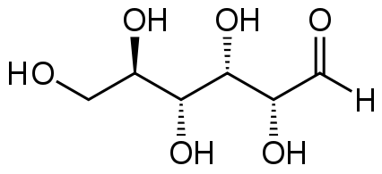

An example of the dehydration of a glucose molecule can be seen from the equation below.
∆H₁
CH₂OH(CH(OH))₄CHO CH₂=C(OH)-CH=C(OH)-CH(OH)-CHO + 2H₂O
Glucose Compound A

(a) Write an equation to define the standard enthalpy change of formation of
glucose. [1]

6C(s) + 3O₂(g) + 6H₂(g) C₆H₁₂O₆ (s)

(b) Using the value(s) given below, calculate ∆H₁. [2]

Enthalpy change of formation of Glucose | -1271 kJ mol⁻¹
Enthalpy change of formation of Compound A | -1085 kJ mol⁻¹
Enthalpy change of combustion of H₂(g) | -286 kJ mol⁻¹
Enthalpy change of atomization of C(s) | +715 kJ mol⁻¹

∆H₁ = ∑∆H_{f} (products) – ∑∆H_{f} (reactants)

= [ –1085 + 2(-286) ] – [–1271]

= – 386 kJ mol⁻¹

(c) Use the data given in (b) and any relevant values from the Data Booklet, draw
an appropriate energy cycle and hence, find the enthalpy change of
sublimation of glucose. [5]
∆H_{f} of C₆H₁₂O₆ (s)

6C(s) + 3O₂ (g) + 6H₂ (g) C₆H₁₂O₆ (s)
6 X ∆H_{at} of C(s)
3 X BE of O₂
6 X BE H₂(g)
∆H_{sublimation} of C₆H₁₂O₆ (s)
∆H_{at} of C₆H₁₂O₆

6C(g) + 6O(g) + 12H (g) C₆H₁₂O₆ (g)

∆H_{at} of C₆H₁₂O₆

= 5(BE of C–C) + 5(BE of C–O) + BE of C=O + 5(BE of O–H) + 7(BE of C–H)

= 5(350) + 5(360) + 740 + 5(460) + 7(410)

= + 9460 kJ mol⁻¹

Using Hess’s Law:

∆H_{f} (C₆H₁₂O₆) + ∆H_{sublimation}(C₆H₁₂O₆) + ∆H_{at} (C₆H₁₂O₆)

= 6∆H_{at} C(s) + 3 Bond Energy of O=O + 6 Bond Energy of H–H

∆H_{sublimation}(C₆H₁₂O₆) = [6(+715) + 3(+496) + 6(+436)] – [(–1271) + (+9460)]

= +205 kJ mol⁻¹

(d) State the total possible number of stereoisomers that glucose can display. [1]

2⁴ = 16

(e) Complete the following scheme by drawing the structures of the organic
compounds B, C, D, E, F and G in the boxes provided. [6]

CH₂=C(OH)-CH=C(OH) -CH(OH)-CHO compound A

KMnO₄/H⁺, heat

HOOC – C – COOH
II
O

Compound B

PCl₅

Cl – C – C – C – Cl
II II II
O O O

Compound C

OH
excess (CH₃)₂NH,
heat in a sealed tube

HCN with NaCN, followed by heating with dilute acid

(CH₃)₂N – C – C – C – N(CH₃)₂
II II II
O O O

Compound D

COOH
I
HO + HOOC – C – COOH
I
OH
Comp
Compound F and Compound G

O – C – C – C – O
II II II
O O O

Compound E

